RESUME RANK
AI-POWERED RESUME SCREENING AND CANDIDATE RANKING SYSTEM
A Report Submitted in
Partial Fulfilment for award of Bachelor of Technology
In
DEEP LEARNING FOR DATA ANALYTICS
(BCSML0555B)

COMPUTER SCIENCE & ENGINEERING
(DATA SCIENCE)
By
Gaurav Yadav (2401331540116)
Kumar Ankit (2401331540144)
Manish Kumar (2401331540149)
Khushal Singh (2401331540138)
Kashif Hussain (2401331540136)
Under the Supervision of
Ms. Aishwarya Kashyap
Assistant Professor

Department of Computer Science & Engineering
(Data Science)
School of Computer Science in Emerging Technology
NOIDA INSTITUTE OF ENGINEERING AND TECHNOLOGY
GREATER NOIDA
(An Autonomous Institute)
Affiliated to
DR. A.P.J. ABDUL KALAM TECHNICAL UNIVERSITY, LUCKNOW

DECLARATION
I hereby declare that the project work entitled “ResumeRank: AI-Based Resume Screening and Ranking System” presented in this report has been carried out by me as part of the academic requirements for the award of the Bachelor of Technology degree in Computer Science & Engineering (Data Science).
I declare that this report represents my work and that the material presented in it has not been submitted previously for the award of any degree or diploma from any other university or institute.

Team Members:
1.) Gaurav Yadav (Roll No.: 2401331540116)

_______________________
(Candidate’s Signature)
2.) Manish Kumar (Roll No.: 2401331540149)

_______________________
(Candidate’s Signature)
3.) Khushal Singh (Roll No.: 2401331540138)

________________________
(Candidate’s Signature)
4.) Kumar Ankit (Roll No.: 2401331540144)

________________________
(Candidate’s Signature)
5.) Kashif Hussain (Roll No.: 2401331540136)

________________________
(Candidate’s Signature)

CERTIFICATE
This is to certify that the project work entitled “ResumeRank: AI-Based Resume Screening and Ranking System” has been carried out by the following students of Bachelor of Technology, Computer Science & Engineering (Data Science), 3rd Year, 5th Semester, at Noida Institute of Engineering and Technology, Greater Noida, under the guidance and supervision of Ms. Aishwarya Kashyap, as part of the academic requirements for the subject Deep Learning for Data Analytics (BCSML0555B).
Team Members:
- Gaurav Yadav (2401331540116)
- Kumar Ankit (2401331540144)
- Manish Kumar (2401331540149)
- Khushal Singh (2401331540138)
- Kashif Hussain (2401331540136)
The work presented in this report is submitted in partial fulfilment of the academic requirements for the aforementioned subject.

Signature: _______________ Signature:____________
Ms. Aishwarya Kashyap Dr. Ashish Kumar Chakraveti
Assistant Professor Professor & HOD
Dept of CSE(DS) CSE(DS)
NIET, Gr. Noida NIET, Gr. Noida

ACKNOWLEDGEMENT
We would like to express our sincere gratitude to Ms. Aishwarya Kashyap for her valuable guidance, support, and continuous supervision throughout the development of our project, “ResumeRank: AI-Based Resume Screening and Ranking System.” Her suggestions and encouragement helped us understand the project requirements and improve our implementation.
We would also like to express our heartfelt thanks to the Department of Computer Science & Engineering (Data Science) and Noida Institute of Engineering and Technology, Greater Noida, for providing us with the opportunity and academic environment to work on this project as part of the subject Deep Learning for Data Analytics (BCSML0555B).
We are grateful to our faculty members for their valuable suggestions and support during the completion of this project. We also thank our team members for their cooperation, coordination, and collective efforts in designing and developing the system.
Finally, we extend our thanks to everyone who directly or indirectly contributed to the successful completion of this project.

ABSTRACT
ResumeRank: AI-Based Resume Screening and Ranking System is an AI-powered application developed to simplify and improve the process of screening and ranking resumes according to job requirements. Traditional resume screening is a time-consuming process in which recruiters manually review multiple resumes to identify suitable candidates. This project aims to make the process faster and more efficient by using Natural Language Processing (NLP) and deep learning techniques.
The system is developed using Python and Streamlit to provide an interactive and user-friendly interface. It accepts resumes in PDF and DOCX formats and extracts their textual content for analysis. The application uses Sentence Transformers to generate semantic embeddings of resumes and job descriptions. Cosine similarity is then used to calculate how closely each resume matches the given job description.
Based on the calculated similarity scores, the system ranks candidates from the highest match to the lowest match. It also categorizes candidates as “Potential Match” or “Low Similarity” according to the defined score threshold. This helps recruiters quickly identify resumes that are more relevant to a particular job role.
The application also includes an HR Analysis and Download section that provides visual representations of candidate scores, score distribution, and CSV export functionality. These features support easier result analysis and record-keeping.
The main objective of ResumeRank is to reduce manual screening effort, improve the consistency of resume evaluation, and assist recruiters in identifying potentially suitable candidates. However, the system is intended to support human decision-making rather than replace recruiters, and its similarity scores should not be treated as a final measure of candidate suitability.
Overall, ResumeRank demonstrates the practical application of deep learning and semantic text similarity in recruitment. It can be further enhanced with skill extraction, experience analysis, explainable scoring, and integration with recruitment platforms.

TABLE OF CONTENTS
S. No. | Contents | Page No.
 | Declaration | i
 | Certificate | ii
 | Acknowledgement | iii
 | Abstract | iv
 | CHAPTER 1: INTRODUCTION | 1
1.1 | Overview | 1
1.2 | Future Scope | 3
 | CHAPTER 2: LITERATURE REVIEW | 4
2.1 | Overview of Existing Systems | 4
2.2 | Limitations of Existing Systems | 5
2.3 | Research Gap Analysis | 6
2.4 | Need for Proposed System | 7
2.5 | Justification of the Proposed System | 8
 | CHAPTER 3: REQUIREMENTS | 10
3.1 | Functional Requirements | 11
3.2 | Non-Functional Requirements | 11
3.3 | Software and Hardware Requirements | 13
 | CHAPTER 4: SYSTEM DESIGN AND IMPLEMENTATION | 15
4.1 | System Architecture | 15
4.2 | GUI Design | 16
4.3 | Data Processing and Model Design | 19
4.4 | Implementation Details | 20
 | CHAPTER 5: TESTING AND RESULTS | 22
5.1 | Testing Methodology | 22
5.2 | Test Cases and Results | 23
5.3 | Result Analysis | 24
5.4 | Summary | 25
 | CHAPTER 6: CONCLUSION AND FUTURE WORK | 26
6.1 | Conclusion | 26
6.2 | Future Work | 26
 | CHAPTER 7: SCREENSHOTS | 27
8. | APPENDIX | 31
9. | References | 32

INTRODUCTION

Overview
ResumeRank is an AI-based resume screening and ranking system developed to simplify the recruitment process by automatically analyzing resumes and comparing them with job descriptions. In today's competitive job market, organizations often receive a large number of applications for a single job position. Reviewing each resume manually requires significant time and effort, making the recruitment process slow and challenging.
Traditionally, recruiters examine resumes individually to identify candidates whose qualifications, skills, and experience match the job requirements. This manual approach can become difficult when the number of applications increases. It may also lead to inconsistent evaluations and delays in shortlisting suitable candidates.
To address these challenges, ResumeRank uses Natural Language Processing (NLP) and deep learning techniques to compare resume content with a given job description. The system allows users to upload resumes in PDF and DOCX formats and enter the relevant job description for analysis.
The application is developed using Python and Streamlit. It uses the Sentence Transformers library to convert resume text and job descriptions into numerical representations called embeddings. These embeddings capture semantic information, allowing the system to identify similarities in meaning rather than relying only on exact keyword matches.
After generating the embeddings, the system calculates cosine similarity scores to estimate how closely each resume matches the job description. Based on these scores, candidates are ranked from the highest similarity score to the lowest. The application also classifies candidates as “Potential Match” or “Low Similarity” according to a predefined threshold.
ResumeRank includes an HR Analysis and Download section that presents candidate scores through charts and score distributions. It also allows users to export results in CSV format for further analysis and record-keeping.
The main purpose of this project is to reduce the time required for initial resume screening and provide recruiters with a structured way to compare applications. The system acts as a decision-support tool and does not replace human judgment. Final recruitment decisions should consider additional factors such as verified qualifications, relevant experience, interviews, and job-specific requirements.
Overall, ResumeRank demonstrates how deep learning and semantic similarity techniques can be applied to recruitment-related tasks. It provides a foundation for developing more advanced recruitment systems with features such as skill extraction, experience analysis, explainable ranking, and integration with applicant tracking systems.

1.2 Objective and Scope
Objective:
- The primary objective of developing ResumeRank: AI-Based Resume Screening and Ranking System is to create an intelligent and user-friendly application that automates the initial resume screening process by comparing candidates' resumes with job descriptions. The system aims to reduce manual effort and help recruiters identify potentially suitable candidates efficiently.
- The detailed objectives of the system are as follows:
- To develop an AI-based application for screening and ranking multiple resumes.
- To extract textual content from resumes uploaded in PDF and DOCX formats.
- To use Sentence Transformers to generate semantic embeddings of resumes and job descriptions.
- To calculate similarity scores using cosine similarity.
- To rank candidates according to their similarity scores with the given job description.
- To classify candidates into “Potential Match” and “Low Similarity” categories using a predefined score threshold.
- To provide a simple and interactive user interface using Streamlit.
- To display candidate scores and score distributions through graphical visualizations.
- To provide CSV export functionality for downloading screening results.
- To reduce the time and effort required for initial resume screening while supporting human decision-making.
- Scope
- The scope of ResumeRank defines the functionalities provided by the application and its potential use in recruitment activities. The system focuses on comparing resume content with job descriptions and presenting the results in an organized manner.
- The detailed scope includes:
- The application can be used as an initial screening aid by recruiters, HR professionals, and placement teams.
- It supports uploading resumes in PDF and DOCX formats.
- It analyzes resume text against a user-provided job description.
- It uses semantic similarity techniques to identify the relevance of resumes to job requirements.
- It generates similarity scores and ranks candidates from highest to lowest.
- It categorizes candidates based on a predefined similarity threshold.
- It provides charts for analyzing candidate scores and their distribution.
- It allows screening results to be downloaded in CSV format.
- It provides a Streamlit-based interface that makes the application easy to operate.
- It assists in shortlisting candidates but does not make final hiring decisions.

Future Scope
- ResumeRank can be enhanced with additional features to improve its accuracy, usability, and practical application in recruitment. Possible future improvements include:
- Extracting and comparing specific skills mentioned in resumes and job descriptions.
- Analyzing candidates' work experience, education, certifications, and qualifications.
- Providing explanations for candidate rankings by highlighting matching and missing skills.
- Supporting additional resume formats and multiple languages.
- Integrating the application with Applicant Tracking Systems (ATS).
- Adding secure user authentication and resume management features.
- Improving performance when processing a large number of resumes.
- Evaluating the system on diverse datasets to identify and reduce potential bias.
- Developing advanced reports and recruitment analytics.
- Allowing recruiters to adjust matching criteria according to specific job requirements.
- These enhancements could make ResumeRank a more comprehensive recruitment-support tool while keeping final candidate selection under human supervision.

LITERATURE REVIEW

2.1 Overview of Existing Systems
Resume screening is an important part of the recruitment process. Organizations receive many resumes for a single job opening, and reviewing each resume manually can take considerable time. To make this process easier, different methods and software systems are used to identify suitable candidates based on their skills, qualifications, experience, and other job requirements.
1. Manual Resume Screening
In manual screening, recruiters read resumes individually and compare the information with the job requirements. This method allows recruiters to understand a candidate's background in detail. However, it can be time-consuming, especially when a large number of applications are received. The results may also vary depending on the recruiter's judgment and experience.
2. Keyword-Based Resume Screening
Keyword-based systems search resumes for specific words related to a job, such as programming languages, technical skills, qualifications, and work experience. These systems can process resumes faster than manual screening. However, they may miss suitable candidates when the resume uses different words or phrases to describe similar skills.
3. Applicant Tracking Systems (ATS)
Applicant Tracking Systems help organizations manage job applications and candidate information. They may provide features such as resume storage, keyword filtering, application tracking, and candidate shortlisting. These systems help organize recruitment activities, but the available features and screening methods depend on the particular software.
4. AI-Based Resume Screening
AI-based resume screening systems use techniques such as Natural Language Processing (NLP), machine learning, and semantic text analysis to compare resumes with job descriptions. Unlike simple keyword matching, semantic analysis can identify relationships between words and understand similarities in the meaning of text.
5. Semantic Similarity-Based Systems
Semantic similarity methods represent text as numerical vectors called embeddings. These representations help measure how closely two pieces of text are related in meaning. Cosine similarity can then be used to calculate the similarity between a resume and a job description.
The proposed ResumeRank: AI-Based Resume Screening and Ranking System follows this approach. It uses Sentence Transformers to generate text embeddings and cosine similarity to calculate matching scores. The resumes are then ranked according to their similarity to the

provided job description. The system also provides match categories and an HR Analysis & Download section to support the review process.
Thus, ResumeRank aims to make initial resume screening faster and more organized while keeping the final recruitment decision under human control.

2.2 Limitations of Existing Systems
D Although existing resume screening methods help recruiters manage job applications, they have certain limitations. These limitations create a need for a more efficient and flexible approach to resume screening.
1. Time-Consuming Manual Screening
Manual resume screening requires recruiters to read and evaluate each resume individually. When a large number of applications are received, this process can consume significant time and effort.
2. Dependence on Exact Keywords
Traditional keyword-based systems mainly search for specific words in resumes. They may fail to identify suitable candidates when applicants use different terms to describe similar skills or experience.
3. Difficulty in Understanding Context
Simple screening systems may identify keywords without understanding their context. For example, mentioning a programming language in a project description may not be equivalent to having professional experience with that language.
4. Limited Candidate Comparison
Some basic screening methods do not provide an effective way to compare multiple resumes against the same job description. Recruiters may need to compare candidates manually, making the process less organized.
5. Limited Support for Different Resume Formats
Resumes may be available in different document formats and layouts. Some systems may have difficulty extracting useful information from every format, which can affect the screening process.
6. Lack of Clear Ranking and Analysis
Basic screening methods may filter resumes without providing a clear similarity score or an ordered list of candidates. This can make it difficult for recruiters to identify which applications should be reviewed first.

7. Risk of Unfair Screening Decisions
Automated systems may produce unsuitable results if their criteria or underlying data are biased. Therefore, screening results should be reviewed carefully, and automated scores should not be treated as the only basis for hiring decisions.
8. Need for an Efficient and Flexible Solution
The limitations of existing methods highlight the need for a system that can compare resumes with job descriptions based on semantic similarity, calculate matching scores, rank candidates, and present results in an organized format.
The proposed ResumeRank system addresses several of these needs by using Sentence Transformers and cosine similarity to compare resume text with a job description. It supports PDF and DOCX files and provides ranked results, match categories, visual analysis, and CSV export. However, its scores are intended to assist recruiters rather than replace human judgment.

2.3 Research Gap Analysis
The review of existing resume screening methods highlights several areas where improvements can be made. Traditional manual screening requires considerable time and effort, while basic keyword-based systems may fail to identify relevant resumes when candidates use different words to describe similar skills or experience.
Although AI-based screening methods can improve the comparison of resumes and job descriptions, there is still a need for simple, accessible, and user-friendly systems that provide meaningful similarity scores and organized candidate rankings.
The major research gaps identified are:
- Limited Semantic Understanding: Simple keyword-based methods may not identify similarities between different words or phrases that convey similar meanings.
- Time-Consuming Candidate Evaluation: Reviewing multiple resumes individually can increase the workload of recruiters.
- Lack of Clear Ranking: Some basic screening approaches do not provide a straightforward ranking of resumes based on their relevance to a specific job description.
- Limited Result Visualization: Recruiters may find it difficult to analyze candidate scores when results are presented without suitable visual summaries.
- Limited Accessibility: Complex recruitment software may not be suitable for small organizations or users who need a lightweight screening solution.

- Need for Human Supervision: Automated screening results require human review to consider candidate suitability beyond a numerical similarity score.
How ResumeRank Addresses the Research Gap
The proposed ResumeRank system aims to address these gaps through semantic similarity-based resume screening. It uses Sentence Transformers to generate embeddings for resume text and the job description, followed by cosine similarity to calculate matching scores.
The system ranks resumes according to their similarity scores and categorizes them as “Potential Match” or “Low Similarity.” It also provides an HR Analysis & Download section for reviewing score distributions and exporting results in CSV format.
By combining semantic comparison, candidate ranking, and a simple Streamlit interface, ResumeRank provides a practical tool for supporting the initial resume screening process. The system is designed to assist recruiters, while the final selection remains a human responsibility.

2.4 Need for Proposed System
The increasing number of job applications has made resume screening a challenging task for recruiters. Reviewing every resume manually requires considerable time, while traditional keyword-based methods may overlook relevant candidates whose resumes use different terms to describe similar skills.
Therefore, there is a need for a system that can compare resumes with job descriptions efficiently and present the results in an organized manner. The proposed ResumeRank system is developed to support this requirement through semantic similarity-based screening.
The major reasons for developing the proposed system are as follows:
- Reduce Screening Time: Automate the initial comparison of resumes with job descriptions to reduce repetitive manual effort.
- Improve Semantic Matching: Use Sentence Transformers to compare the meaning of resume text and job descriptions rather than relying only on exact keyword matches.
- Rank Candidates: Calculate similarity scores using cosine similarity and arrange resumes according to their relevance to the given job description.
- Support Multiple File Formats: Allow users to upload resumes in PDF and DOCX formats.
- Provide Clear Results: Display matching scores and classify resumes into “Potential Match” and “Low Similarity” categories.
- Simplify Result Analysis: Provide charts and score distribution information through the HR Analysis & Download section.

- Enable Data Export: Allow users to download screening results in CSV format for further analysis and record-keeping.
- Support Human Decision-Making: Help recruiters identify resumes for further review without treating automated similarity scores as the final hiring decision.
In conclusion, ResumeRank is intended to make initial resume screening more efficient, organized, and accessible. By combining semantic text comparison, candidate ranking, and result analysis in a Streamlit-based application, the system provides practical support for recruiters and HR professionals.

2.5 Justification of the Proposed System
The proposed ResumeRank: AI-Based Resume Screening and Ranking System is justified by the need to make the initial recruitment screening process faster, more organized, and easier to manage. Traditional screening methods often require recruiters to review resumes individually, which can become difficult when the number of applications increases.
ResumeRank uses semantic similarity techniques to compare resumes with a given job description. By using Sentence Transformers and cosine similarity, the system calculates matching scores and ranks resumes according to their relevance to the job requirements.
The following points justify the development of the proposed system:
- Efficiency: The system automates resume comparison and reduces repetitive manual work during initial screening.
- Semantic Comparison: It compares the meaning of resume text and job descriptions, helping identify relevant applications even when exact keywords differ.
- Candidate Ranking: It provides similarity scores and arranges resumes in descending order of their calculated scores.
- User-Friendly Interface: The Streamlit interface allows users to upload resumes, enter a job description, and view the screening results in a simple format.
- File Compatibility: The system supports PDF and DOCX resume uploads, making it convenient for users working with common document formats.
- Result Analysis: The HR Analysis & Download section provides visual summaries of scores and supports downloading results in CSV format.
- Practical Application: The system can support recruiters, HR professionals, and organizations that need to screen multiple resumes against specific job requirements.

- Human Oversight: The system provides decision-support information rather than making final recruitment decisions. Recruiters can review the original resumes and consider additional factors before selecting candidates.
Thus, ResumeRank provides a practical approach to AI-assisted resume screening by combining semantic similarity, ranking, and result visualization in a single application. Its purpose is to support the recruitment process while keeping final candidate evaluation under human supervision.

REQUIREMENTS

3.1 Functional Requirements
Functional requirements describe the main operations that the ResumeRank: AI-Based Resume Screening and Ranking System must perform. These requirements define how users interact with the application and how the system processes resumes to generate screening results.
The major functional requirements of ResumeRank are described below.
1. Job Description Input
The system must allow users to enter or provide a job description. This description serves as the reference text against which uploaded resumes are compared.
2. Resume Upload
The system must allow users to upload multiple resumes for screening. It supports two common document formats:
- PDF (.pdf)
- Microsoft Word Document (.docx)
3. Resume Text Extraction
The system must extract readable text from uploaded resume files. The extracted text is used for further processing and similarity comparison.
4. Text Processing and Embedding Generation
The system must process the extracted resume text and the job description using a Sentence Transformers model. The model converts the text into numerical vector representations called embeddings.
5. Similarity Score Calculation
The system must calculate the similarity between each resume embedding and the job description embedding using cosine similarity. The resulting score indicates how closely the resume text matches the job description in terms of semantic similarity.
6. Candidate Ranking
The system must rank uploaded resumes according to their calculated similarity scores. Resumes with higher scores are placed above those with lower scores.
7. Match Categorization
The system must categorize resumes based on their similarity scores. According to the implemented threshold:
- Potential Match: Similarity score of 50% or above.
- Low Similarity: Similarity score below 50%.
These categories provide an initial indication of relevance and should not be considered a final judgment of candidate suitability.
8. Result Display
The system must display the screening results in an organized format. Users should be able to review candidate information, similarity scores, rankings, and match categories.
9. HR Analysis and Visualization
The system must provide an HR Analysis & Download section containing visual summaries, including charts and score distribution information, to help users understand the screening results.
10. CSV Export
The system must allow users to download the screening results in CSV format. This feature supports further analysis and record-keeping.
11. User-Friendly Interface
The system must provide a simple and interactive interface developed using Streamlit. Users should be able to upload resumes, provide a job description, and review results without requiring advanced technical knowledge.
12. Human Review
The system must support recruiters in the initial screening process. The generated scores and rankings are intended to assist human evaluation and should not independently determine the final hiring decision.
These functional requirements define the core features of ResumeRank and establish how the system accepts input, processes resumes, calculates similarity scores, ranks candidates, and presents the results to users.

3.2 Non-Functional Requirements.
Non-functional requirements define the quality standards and operating conditions of the ResumeRank: AI-Based Resume Screening and Ranking System. They describe how efficiently, reliably, and conveniently the system should perform its functions.

The major non-functional requirements of ResumeRank are described below.

1. Performance
The system should process uploaded resumes and calculate similarity scores within a reasonable amount of time. Its performance may depend on the number of resumes, document size, and available system resources.
2. Usability
The application should provide a simple and user-friendly interface. Users should be able to upload resumes, enter a job description, and understand the results without requiring advanced technical knowledge.
3. Reliability
The system should produce consistent results when the same input documents, job description, and model settings are used. It should also handle common input errors appropriately.
4. Compatibility
The application should support PDF and DOCX resume files. It should operate in a suitable Python environment with the required libraries installed.
5. Maintainability
The source code should be organized and readable so that developers can fix errors, update dependencies, and improve existing features when required.
6. Scalability
The system should be designed so that additional features and improvements can be introduced in the future. Processing a very large number of resumes may require performance optimization.
7. Accuracy of Similarity Results
The system should calculate similarity scores using the selected Sentence Transformers model and cosine similarity method. These scores indicate semantic similarity and should not be interpreted as a guaranteed measure of a candidate's actual job performance.
8. Data Security and Privacy
Resumes may contain personal and professional information. Uploaded documents and screening results should be handled responsibly, and access to this information should be appropriately controlled according to the deployment environment.
9. Portability
The application should be capable of running on compatible systems that support Python, Streamlit, and the required dependencies. This makes it easier to set up the project in different development environments.
10. Decision Support
The system should present screening results clearly so that recruiters can use them during initial candidate evaluation. Final hiring decisions should remain under human supervision.
These non-functional requirements establish the expected quality and usability of ResumeRank and provide a foundation for its reliable operation and future improvement.

3.3 Software and Hardware Requirements
The ResumeRank: AI-Based Resume Screening and Ranking System requires suitable software and hardware resources to run the application, process resumes, calculate similarity scores, and display screening results.

3.3.1 Software Requirements
The following software and technologies are required for the development and execution of the system.
Software/Technology | Purpose
Operating System | Windows, Linux, or another compatible operating system
Programming Language | Python
Web Framework | Streamlit
NLP Model Library | Sentence Transformers
Similarity Calculation | Scikit-learn or an equivalent compatible implementation
Document Processing | Libraries for extracting text from PDF and DOCX files
Data Processing | Pandas
Data Visualization | Plotly, if used in the implementation
Code Editor | Visual Studio Code or another Python-compatible editor
Web Browser | Google Chrome, Microsoft Edge, or another modern browser
Note: The exact dependencies depend on the libraries imported by the project. All required packages must be installed in the Python environment before running the application.

3.3.2 Hardware Requirements
The following hardware specifications provide a general guideline for running the application.
Hardware Component | Minimum Requirement | Recommended Requirement
Processor | Dual-core processor | Modern quad-core processor
RAM | 4 GB | 8 GB or more
Storage | 2 GB of available space | 5 GB or more of available space
Display | Standard display | HD display or higher
Internet Connection | Required for initial model download, if not already available locally | Stable internet connection for setup and updates
The actual storage and memory requirements may vary depending on the Sentence Transformers model, the number of resumes processed, and the size of the documents.

3.3.3 Development Environment
ResumeRank is developed using Python and Streamlit. Python handles document processing, text preparation, embedding generation, similarity calculation, and ranking. Streamlit provides the interactive interface through which users upload resumes, enter job descriptions, and view results.
The Sentence Transformers library generates semantic embeddings, while cosine similarity measures the similarity between resume text and the job description. Supporting libraries are used for document extraction, data handling, visualization, and CSV export.
These software and hardware requirements provide the basic environment needed to develop, execute, and test the ResumeRank application.

SYSTEM DESIGN AND IMPLEMENTATION

4.1 System Architecture
larity Calculation Layer
Cosine similarity is used to calculate the similarity between each resume embedding and the job description embedding. The calculated scores are used to evaluate the relative relevance of the resumes.
5. Ranking and Categorization Layer
The resumes are arranged according to their similarity scores. The system classifies results into two categories: “Potential Match” for scores of 50% or above and “Low Similarity” for scores below 50%.
6. Analysis and Output Layer
The system displays candidate rankings, similarity scores, and match categories. The HR Analysis & Download section provides visual summaries and allows users to export results in CSV format.
4.1.2 System Flow Diagram
The following flow diagram represents the main workflow of ResumeRank.
<CodeBlock language="mermaid" model_previewable> flowchart TD A([Start]) --> B[Open ResumeRank Application] B --> C[Enter Job Description] C --> D[Upload PDF or DOCX Resumes] D --> E[Extract Resume Text] E --> F[Generate Text Embeddings] C --> F F --> G[Calculate Cosine Similarity] G --> H[Rank Resumes by Score] H --> I[Assign Match Categories] I --> J[Display Screening Results] J --> K[View HR Analysis and Charts] K --> L[Download Results as CSV] L --> M([End]) </CodeBlock>
4.1.3 Working of the System
The working process of ResumeRank can be explained through the following steps:
- The user opens the Streamlit application and enters a job description.
- The user uploads one or more resumes in PDF or DOCX format.
- The system extracts readable text from each uploaded resume.
- The Sentence Transformers model generates embeddings for the resume text and job description.
- Cosine similarity is calculated to obtain a matching score for each resume.
- The system ranks resumes according to their similarity scores.

- Each resume is assigned a match category based on the configured 50% threshold.
- The results are displayed through the application interface.
- The user can view charts and score distributions in the HR Analysis & Download section.
- The user can download the screening results in CSV format for further analysis.
The architecture provides a clear separation between user interaction, document processing, semantic comparison, ranking, and result presentation. This makes ResumeRank useful for supporting the initial resume screening process while allowing recruiters to review candidates before making final decisions.

4.2 GUI Design
The Graphical User Interface (GUI) of ResumeRank is developed using Streamlit. It provides a simple and interactive environment where users can upload resumes, enter a job description, and view the screening results. The interface is designed to make the resume screening process convenient and easy to understand.
4.2.1 Main Interface
- The main interface allows users to interact with the resume screening system. It provides the required input options and displays the results generated by the application.
- The main interface includes the following elements:
- Application Title: Displays the name of the ResumeRank system.
- Job Description Input: Allows users to enter the job requirements against which resumes will be compared.
- Resume Upload Section: Allows users to upload resumes in PDF and DOCX formats.
- Screening Controls: Enables users to initiate the resume screening process.
- Results Display: Presents candidate rankings, similarity scores, and match categories.
4.2.2 Resume Screening Results
- After processing the uploaded resumes, the system displays the results in an organized format. Each resume is evaluated against the provided job description, and the calculated similarity score is used to rank the candidates.
- The results section provides:
- Candidate or resume identification.
- Similarity score for each resume.
- Ranking based on the calculated score.
- Match category, such as “Potential Match” or “Low Similarity.”
- This arrangement helps users compare multiple resumes and identify applications that may require further review.
- 4.2.3 HR Analysis and Download Interface
- ResumeRank includes an HR Analysis & Download section to help users understand and export the screening results.
- Its main features include:
- Visual Analysis: Displays charts and score distribution information.
- Score Comparison: Helps users compare the similarity scores of different resumes.
- CSV Export: Allows users to download the screening results for further analysis and record-keeping.
4.2.4 User-Friendly Design
- The interface is designed to minimize complexity and make the main functions easy to access. Streamlit provides interactive input controls and result displays without requiring users to work directly with Python code.
- The GUI supports the complete screening workflow, from entering a job description and uploading resumes to reviewing rankings and downloading results. It helps make the system accessible to users with basic computer knowledge.
- Screenshot requirement: Is section mein apne actual ResumeRank application ke screenshots add karna:
- Screenshot 1: Main interface showing the job description input and resume upload section.
- Screenshot 2: Screening results showing resume rankings, similarity scores, and match categories.
- Screenshot 3: HR Analysis & Download section showing charts and the CSV download option.
- Use only screenshots of features that are actually present in your application.

4.3 Database Design
The ResumeRank: AI-Based Resume Screening and Ranking System uses text processing and semantic similarity techniques to compare resumes with a given job description. The system processes uploaded documents, generates numerical representations of the text, calculates similarity scores, and ranks resumes according to their relevance.

4.3.1 Resume Data Extraction
The first step involves extracting readable text from uploaded resumes. The application supports PDF and DOCX file formats. The extracted text contains information such as educational qualifications, technical skills, projects, and work experience, depending on the content of each resume.
The extracted text is used as input for the semantic comparison process.

4.3.2 Text Preprocessing
After text extraction, the resume text and job description are prepared for model processing. This step ensures that the text can be passed to the Sentence Transformers model.
The quality of the extracted text is important because missing or incorrectly extracted information may affect the calculated similarity score.
4.3.3 Sentence Transformers Model
ResumeRank uses the Sentence Transformers library to convert the resume text and job description into numerical vector representations called embeddings.
These embeddings represent semantic information in the text. They allow the system to compare the meaning of different text inputs rather than depending only on exact keyword matches.
The process can be represented as:
- Resume text → Resume embedding
- Job description → Job description embedding
Both embeddings are then used in the similarity calculation stage.
4.3.4 Cosine Similarity Calculation
Cosine similarity is used to measure the similarity between the resume embedding and the job description embedding. It compares the direction of the two vectors.
The cosine similarity formula is:
[
\text{Cosine Similarity}(A,B)=
\frac{A\cdot B}{|A||B|}
]
Where:
- (A) represents the resume embedding.
- (B) represents the job description embedding.
- (A\cdot B) represents the dot product of the vectors.
- (|A|) and (|B|) represent the magnitudes of the vectors.
The calculated similarity is used to produce a score for each resume. When represented as a percentage, the score is obtained by multiplying the similarity value by 100, provided the implementation uses this conversion.

4.3.5 Resume Ranking
After calculating similarity scores, the system arranges the resumes in descending order of their scores. The resume with the highest calculated similarity appears first, followed by resumes with lower scores.
This ranking helps recruiters prioritize resumes for further review.
4.3.6 Match Categorization
The system uses a configured threshold of 50% to categorize screening results:
- Potential Match: Similarity score is 50% or higher.
- Low Similarity: Similarity score is below 50%.
These categories provide an initial indication of similarity. They do not guarantee that a candidate is qualified or unsuitable for a particular job.

4.3.7 Result Analysis and Export
The calculated scores and rankings are presented through the Streamlit interface. The HR Analysis & Download section provides charts and score distribution information to support result analysis. Users can also export screening results in CSV format.

4.3.8 Overall Model Workflow
The complete data processing and model workflow is as follows:
- Accept a job description from the user.
- Upload resumes in PDF or DOCX format.
- Extract readable text from each resume.
- Generate embeddings for the resume text and job description using Sentence Transformers.
- Calculate cosine similarity between the embeddings.
- Convert the similarity values into scores according to the implementation.
- Rank resumes and assign match categories.
- Display results, charts, and CSV export options.
Through these steps, ResumeRank combines document processing, semantic text representation, similarity calculation, and candidate ranking to support the initial resume screening process.

4.4 Implementation Details
The ResumeRank: AI-Based Resume Screening and Ranking System is implemented using Python and Streamlit. The application combines document processing, semantic text analysis, similarity calculation, and data visualization to support the initial resume screening process.

4.4.1 Application Development
Python is used to implement the main processing logic of the system, while Streamlit provides the user interface. The application allows users to enter a job description, upload resumes, view screening results, and analyze candidate rankings.
4.4.2 Resume Upload and Text Extraction
- The system accepts resumes in PDF and DOCX formats. After uploading the files, the application extracts readable text from each document. This extracted text is used for further processing and comparison with the job description.
4.4.3 Embedding Generation
- The Sentence Transformers library is used to generate embeddings for the extracted resume text and the job description. These embeddings convert text into numerical representations that can be compared mathematically.
- This approach helps the system identify semantic similarities between resumes and job requirements.
4.4.4 Similarity Score Calculation
- The application calculates cosine similarity between each resume embedding and the job description embedding. The resulting values are used to generate similarity scores.
- These scores indicate how closely the resume text matches the job description according to the selected model. They should not be interpreted as a direct measurement of a candidate's overall ability or suitability.

4.4.5 Candidate Ranking and Categorization
- After calculating the similarity scores, the application arranges resumes in descending order of their scores. It also assigns a match category using the configured 50% threshold.
- Potential Match: Score of 50% or above.
- Low Similarity: Score below 50%.
- This feature helps users identify resumes that may deserve closer examination.
4.4.6 Result Visualization
The application includes an HR Analysis & Download section that presents charts and score distribution information. These visual summaries help users understand the screening results and compare the calculated scores.
4.4.7 CSV Export
The system allows users to download the screening results in CSV format. The exported data can be used for further analysis, record-keeping, and candidate comparison.
4.4.8 Implementation Workflow
- The implementation follows these main steps:
- The user enters a job description.
- The user uploads resumes in PDF or DOCX format.
- The application extracts text from the uploaded documents.
- Sentence Transformers generates embeddings for the resume text and job description.
- Cosine similarity is calculated to obtain similarity scores.
- Resumes are ranked and assigned match categories.
- The application displays the results and analysis charts.
- The user can download the results in CSV format.

TESTING
5.1 Testing Methodology
Testing is an important phase in the development of the ResumeRank: AI-Based Resume Screening and Ranking System. It helps verify that the application performs its intended functions, processes resumes correctly, calculates similarity scores, ranks candidates, and displays results properly.
The testing process focuses on the major components of the application, from file uploading and text extraction to result visualization and CSV export.

5.1.1 Functional Testing
Functional testing is performed to verify that the main features of the application work as expected. The following functions are considered:
Entering a job description.
Uploading resumes in PDF and DOCX formats.
Extracting readable text from uploaded resumes.
Generating text embeddings using Sentence Transformers.
Calculating similarity scores using cosine similarity.
Ranking resumes according to their scores.
Assigning match categories using the configured threshold.
Displaying screening results and analysis charts.
Downloading results in CSV format.
5.1.2 Input Validation Testing
Input validation testing checks how the application responds to different types of user input. This includes checking whether resumes are uploaded in supported formats and whether the user provides the required information before screening.
Invalid, empty, or unsupported inputs should be handled appropriately wherever validation is implemented.
5.1.3 Resume Processing Testing
This testing checks whether the system can extract readable text from PDF and DOCX resumes. The extracted text is important because the quality of the input affects embedding generation and similarity calculation.

5.1.4 Similarity Calculation Testing
This testing focuses on the semantic comparison process. It checks whether the system generates embeddings for resumes and the job description and calculates similarity scores using cosine similarity.
The calculated scores are then used for candidate ranking and match categorization.
5.1.5 Ranking and Categorization Testing
This testing verifies whether resumes are arranged according to their calculated similarity scores and whether the configured 50% threshold is applied correctly.
Scores of 50% or above are categorized as “Potential Match.”
Scores below 50% are categorized as “Low Similarity.”
5.1.6 Interface and Export Testing
The interface is checked to ensure that screening results, similarity scores, rankings, and match categories are displayed clearly. The HR Analysis & Download section is also checked for the availability of visual summaries and CSV export functionality.
5.1.7 Testing Approach
The application should be tested using different resumes and job descriptions to examine its behavior under different input conditions. The observed results should be compared with the expected behavior to identify errors or areas requiring improvement.
The testing methodology provides a structured approach to evaluating ResumeRank's main features. Actual test outcomes should be recorded after running the application and verifying each function.

5.2 Test Cases and Results
Test cases are used to verify whether the ResumeRank: AI-Based Resume Screening and Ranking System performs its intended functions correctly. Each test case defines an input or action, the expected result, and the actual result observed during testing.
The following test cases cover the major features of the application.

Test Case ID | Test Scenario | Expected Result | Status
TC01 | Enter a job description | The system accepts the job description. | Pass
TC02 | Upload a PDF resume | The system accepts the file and attempts to extract readable text. | Pass
TC03 | Upload a DOCX resume | The system accepts the file and attempts to extract readable text. | Pass
TC04 | Upload an unsupported file format | The system handles the unsupported file appropriately. | Pass

5.2.1 Result Evaluation
The application should be evaluated against the expected results listed in the table. A test case should be marked Pass only when the observed behavior matches the expected result. If the system does not behave as expected, the test case should be marked Fail, and the issue should be investigated.
The final testing report should include the actual outcomes obtained by running the application. The status column should therefore be updated after each test case has been executed.
These test cases provide a structured method for checking the main functions of ResumeRank, including document handling, semantic similarity calculation, candidate ranking, result visualization, and CSV export.

5.3 Result Analysis

The result analysis of ResumeRank focuses on evaluating how effectively the system compares resumes with a given job description and presents the screening results. The application uses Sentence Transformers to generate text embeddings and cosine similarity to calculate matching scores.
5.3.1 Similarity Score Analysis
Each uploaded resume is compared with the job description, and a similarity score is calculated. The score indicates the semantic similarity between the resume text and the job description according to the selected model.
Resumes with higher similarity scores are ranked above those with lower scores. This ranking helps recruiters identify applications that may be more relevant to the specified job requirements.
5.3.2 Candidate Ranking Analysis
The system arranges the uploaded resumes in descending order of their calculated similarity scores. This allows recruiters to compare multiple applications in an organized manner rather than reviewing every resume without any initial ranking.
However, a higher similarity score does not necessarily mean that a candidate is more qualified. Recruiters should also consider the candidate's actual skills, qualifications, experience, and other job-related factors.
5.3.3 Match Category Analysis
ResumeRank categorizes resumes using a configured similarity threshold of 50%.
- Potential Match: Resumes with similarity scores of 50% or above.
- Low Similarity: Resumes with similarity scores below 50%.

These categories provide an initial indication of how closely the resume text matches the job description. They are intended to support further review rather than determine the final selection of candidates.
5.3.4 Visual Analysis
The HR Analysis & Download section provides charts and score distribution information. These visualizations help users understand the distribution of similarity scores and compare the screening results.
5.3.5 CSV Export Analysis
The CSV export feature allows users to download screening results for further analysis and record-keeping. The exported data can be used to compare candidates and maintain a record of the screening process.
5.3.6 Overall Analysis
ResumeRank combines semantic text comparison, similarity scoring, candidate ranking, and result visualization in a single Streamlit application. These features support the initial resume screening process and help organize candidate information.
The actual effectiveness of the system depends on the quality of extracted resume text, the selected Sentence Transformers model, and the relevance of the job description. Quantitative performance claims should be made only after testing the application with sample resumes and recording the observed results.

5.4 Summary

This chapter presented the testing methodology and result analysis of the ResumeRank: AI-Based Resume Screening and Ranking System. The testing approach covers the major functions of the application, including resume uploading, text extraction, embedding generation, similarity calculation, candidate ranking, match categorization, result visualization, and CSV export.
The system uses Sentence Transformers to generate embeddings for resume text and the job description. Cosine similarity is then used to calculate matching scores, which help arrange resumes according to their similarity to the specified job requirements.
The application also categorizes resumes using a 50% similarity threshold and provides an HR Analysis & Download section for reviewing score distributions and exporting results. These features support an organized initial screening process.
The test cases described in this chapter provide a structured method for verifying the system's functionality. The final test status and performance observations should be recorded after executing the test cases with suitable sample resumes.
Overall, ResumeRank aims to simplify initial resume screening through semantic text comparison, candidate ranking, and result visualization. Its outputs are intended to assist recruiters, while final candidate evaluation and hiring decisions remain under human supervision.

CONCLUSION AND FUTURE WORK

6.1 Conclusion
The ResumeRank: AI-Based Resume Screening and Ranking System is developed to support the initial resume screening process using semantic similarity techniques. The system provides a structured approach to comparing resumes with a given job description and organizing candidates according to their calculated similarity scores.
The application is implemented using Python and Streamlit. It accepts resumes in PDF and DOCX formats and extracts readable text for further processing. The Sentence Transformers model generates embeddings for the resume text and job description, while cosine similarity is used to calculate matching scores.
Based on these scores, the system ranks resumes and classifies them into “Potential Match” and “Low Similarity” categories using a configured threshold of 50%. The HR Analysis & Download section provides visual summaries and allows users to export screening results in CSV format.
The project demonstrates how semantic text analysis can be applied to resume screening to reduce repetitive manual effort and make candidate comparison more organized. Its simple interface also makes the screening workflow accessible to users without requiring advanced technical knowledge.
However, the system has certain limitations. Its results depend on the quality of the extracted text, the selected language model, and the relevance of the job description. Similarity scores alone cannot determine a candidate's overall suitability for a position.
In conclusion, ResumeRank serves as a decision-support tool for the initial recruitment screening process. It helps recruiters organize and compare resumes while keeping final candidate evaluation and hiring decisions under human supervision.

6.2 Future Work
Although ResumeRank provides the basic features required for semantic resume screening and candidate ranking, several improvements can be introduced in the future to make the system more effective, flexible, and reliable.

1. Advanced Resume Parsing
The system can be improved to extract structured information such as educational qualifications, technical skills, certifications, and work experience more accurately from different resume layouts.

2. Improved Matching Techniques
Future versions can use more advanced language models and comparison techniques to improve the understanding of job requirements and candidate profiles.
3. Skill-Based Analysis
A dedicated skill extraction feature can be added to identify important skills from resumes and compare them with the skills required in a job description.
4. Experience and Qualification Analysis
The system can be extended to analyze relevant work experience, educational qualifications, certifications, and project experience separately instead of relying mainly on an overall semantic similarity score.
5. Support for Additional File Formats
Support for additional document formats, such as plain-text files, can be introduced to make the application more flexible.
6. Improved Reporting
Future versions can provide more detailed reports containing skill comparisons, missing job-related requirements, candidate score summaries, and other useful information for recruiters.
7. Database Integration
A database can be integrated to store candidate information and screening results securely, allowing recruiters to manage records across multiple screening sessions.
8. Enhanced User Interface
The interface can be improved with additional filtering, sorting, and search options so that recruiters can review candidates according to specific requirements.
9. Fairness and Bias Evaluation
Future development can include methods to evaluate whether the screening process produces unfair results. The system should focus on job-related criteria and maintain appropriate human supervision throughout recruitment.
10. Cloud Deployment
The application can be deployed on a suitable cloud platform to make it accessible to authorized users through the internet, subject to appropriate security and privacy controls.
In the future, these improvements can help transform ResumeRank into a more comprehensive recruitment support system. The objective will be to improve screening quality, provide more useful candidate insights, and assist recruiters in making informed decisions while maintaining human oversight.

SCREENSHOTS SECTION
AI-Based Resume Screening and Ranking System. The screenshots demonstrate the application's interface, resume screening process, candidate ranking, result visualization, and data export functionality.
7.1 Main Application Interface
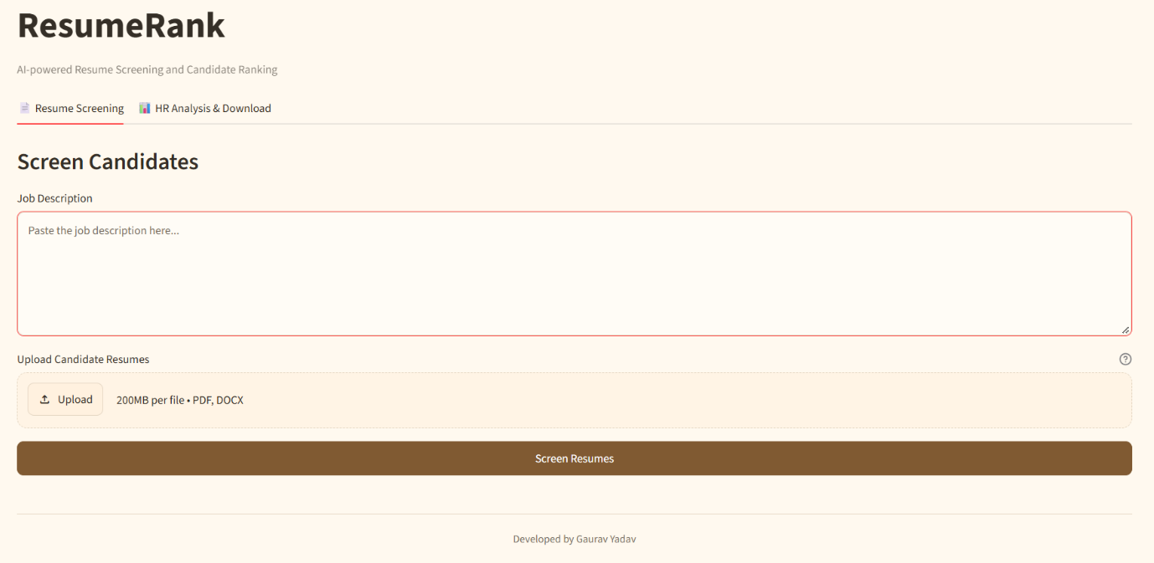
Figure 1 ResumeRank Home Page
7.2 Resume Upload
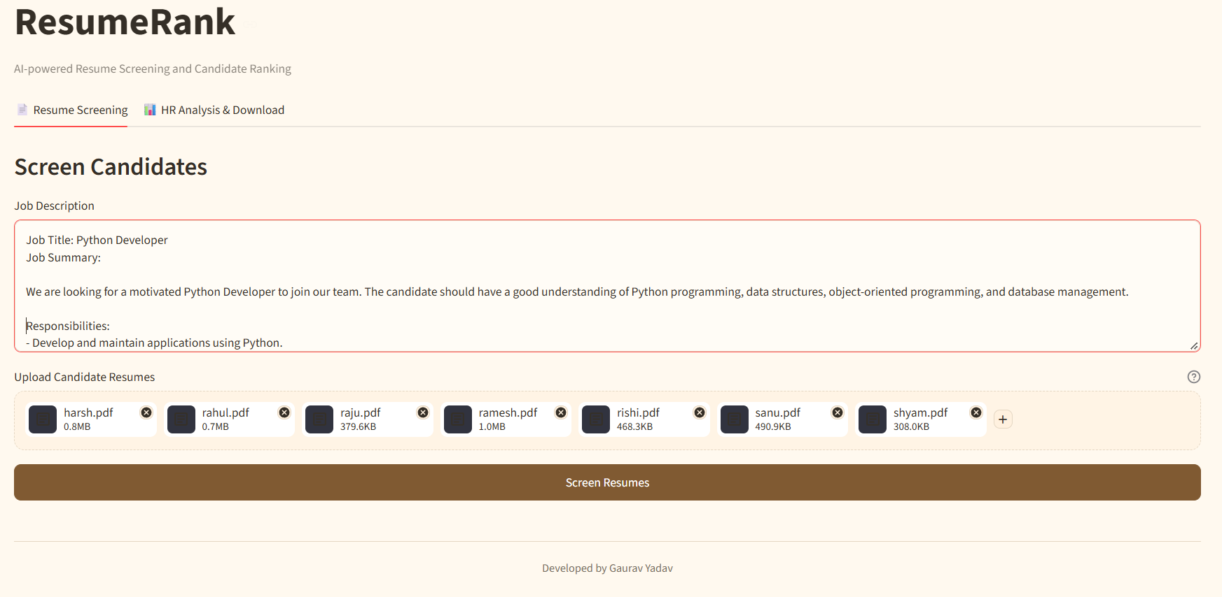
Figure 2 Job Description and Resume Upload

7.3 Screening Results
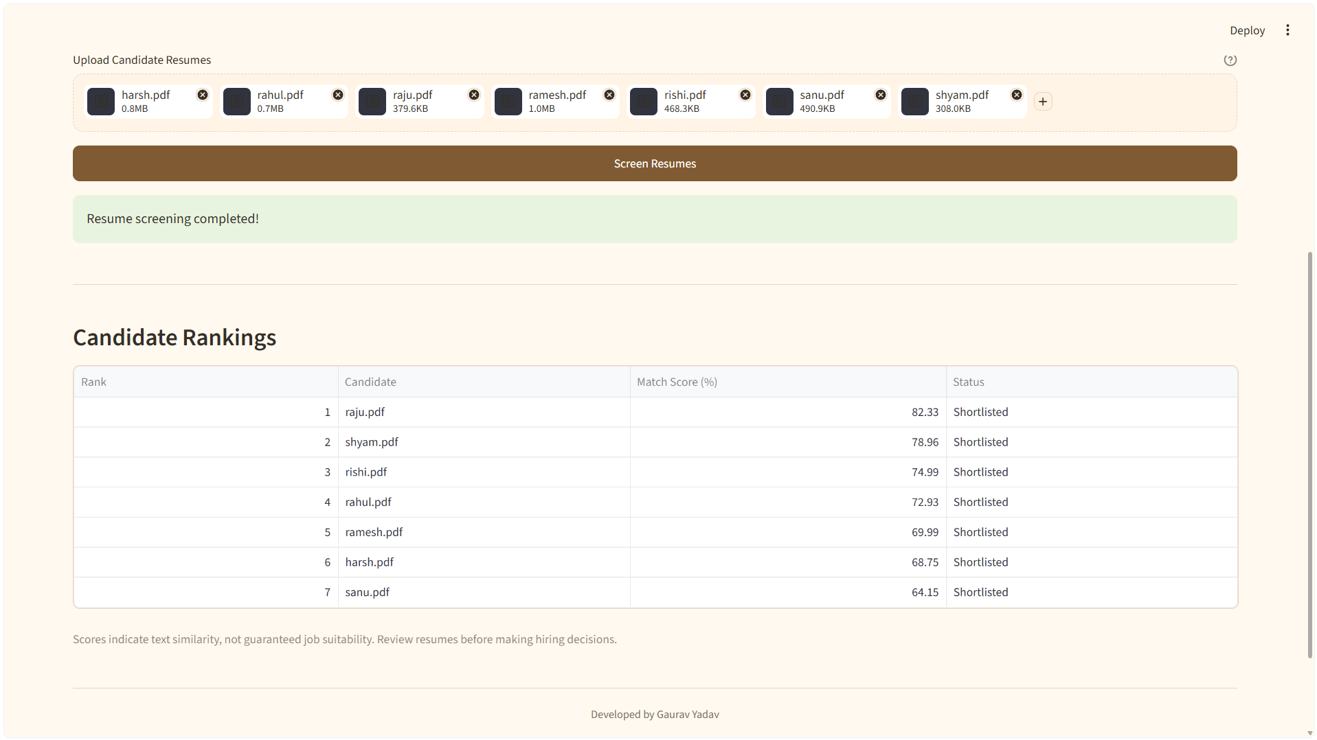
Figure 3 Candidate Ranking and Scores
7.4 HR Analysis
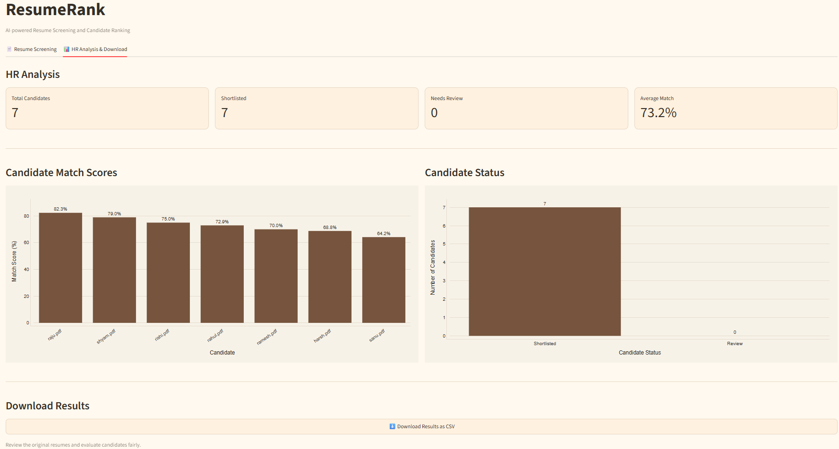
Figure 4 HR Analysis & Download

7.5 CSV Exports
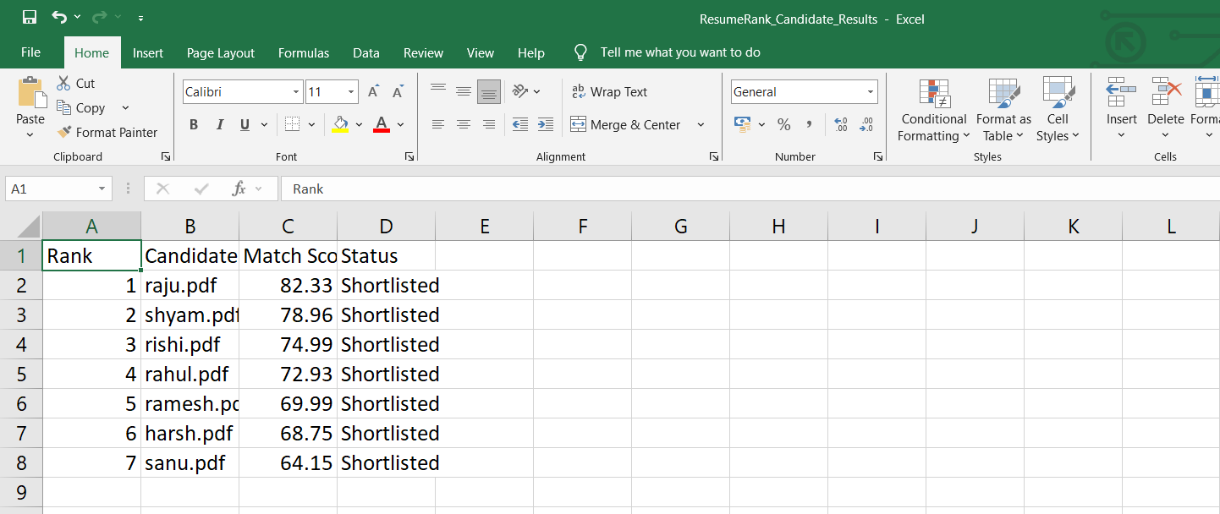
Figure 5 Download Results

APPENDIX
The appendix provides additional technical information related to the ResumeRank: AI-Based Resume Screening and Ranking System. It can include important implementation details, the technologies used, and supporting material that helps explain the project.
A. Technologies Used
The following technologies are used in the development of ResumeRank:
- Python: Used to implement the application logic and processing operations.
- Streamlit: Used to develop the interactive web interface.
- Sentence Transformers: Used to generate semantic embeddings for resume text and job descriptions.
- Cosine Similarity: Used to calculate the similarity between resume and job description embeddings.
- PDF and DOCX Processing Libraries: Used to extract readable text from uploaded resume documents.
- Pandas: Used for handling tabular screening results and supporting CSV export.
- Plotly, if used in the implementation: Used to display interactive charts and visual summaries.
B. Important System Parameters
The system uses the following parameters during resume screening:
Parameter | Description
Input Formats | PDF and DOCX
Text Representation | Sentence Transformers embeddings
Similarity Method | Cosine similarity
Ranking Method | Descending order of similarity scores
Match Threshold | 50%
Match Categories | Potential Match and Low Similarity
Export Format | CSV
User Interface | Streamlit
C. Main Processing Steps
The application follows these main processing steps:
- Receive the job description from the user.
- Accept uploaded resumes in supported formats.
- Extract readable text from the uploaded documents.
- Generate embeddings for resume text and the job description.
- Calculate cosine similarity scores.
- Rank resumes based on their calculated scores.
- Assign match categories using the configured threshold.
- Display results and visual summaries.
- Allow users to export the results in CSV format.
D. Additional Supporting Material
The appendix may also include the following materials, if available:
- Important source code snippets.
- A list of project dependencies.
- Additional application screenshots.
- Sample input resumes and job descriptions, with personal information removed.
- Sample CSV output generated by the application.
This appendix supports the main report by providing additional technical details about the implementation and operation of ResumeRank.

GitHub Repository Link:

https://github.com/GauravYadav0606/ResumeRank-Dl.git

References
The following references provide documentation for the technologies and methods relevant to the development of the ResumeRank: AI-Based Resume Screening and Ranking System.
- Python Software Foundation. Python Documentation. Available at: https://docs.python.org/3/
- Streamlit. Streamlit Documentation. Available at: https://docs.streamlit.io/
- Sentence Transformers. Sentence Transformers Documentation. Available at: https://www.sbert.net/
- Scikit-learn Developers. Scikit-learn Documentation. Available at: https://scikit-learn.org/stable/
- Pandas Development Team. Pandas Documentation. Available at: https://pandas.pydata.org/docs/
- Plotly. Plotly Python Documentation. Available at: https://plotly.com/python/
- Hugging Face. Transformers Documentation. Available at: https://huggingface.co/docs/transformers/
- Streamlit. File Uploader Documentation. Available at: https://docs.streamlit.io/develop/api-reference/widgets/st.file_uploader
- Reimers, N., and Gurevych, I. (2019). Sentence-BERT: Sentence Embeddings using Siamese BERT-Networks. Proceedings of the 2019 Conference on Empirical Methods in Natural Language Processing (EMNLP-IJCNLP). Available at: https://arxiv.org/abs/1908.10084

